**WEEK 5**

**Microservices with Spring Boot 3 and Spring Cloud**

AccountController.java

**package** com.cognizant.account;

**import** org.springframework.web.bind.annotation.GetMapping;

**import** org.springframework.web.bind.annotation.PathVariable;

**import** org.springframework.web.bind.annotation.RestController;

**import** java.util.Map;

@RestController

**public** **class** AccountController {

@GetMapping("/accounts/{number}")

**public** Map<String, Object> getAccountDetails(@PathVariable String number) {

**return** Map.*of*(

"number", number,

"type", "savings",

"balance", 234343

);

}

}

**OUTPUT:**

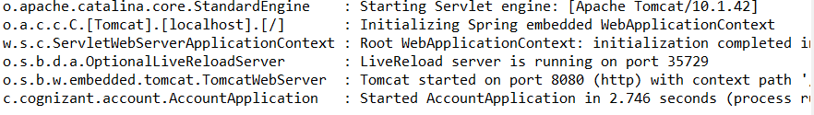

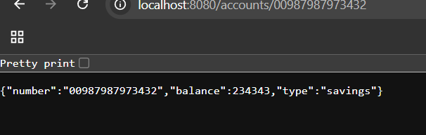

LoanController.java

**package** com.cognizant.loan;

**import** org.springframework.web.bind.annotation.GetMapping;

**import** org.springframework.web.bind.annotation.PathVariable;

**import** org.springframework.web.bind.annotation.RestController;

**import** java.util.Map;

@RestController

**public** **class** LoanController {

@GetMapping("/loans/{number}")

**public** Map<String, Object> getLoanDetails(@PathVariable String number) {

**return** Map.*of*(

"number", number,

"type", "car",

"loan", 400000,

"emi", 3258,

"tenure", 18

);

}

}

**OUTPUT:**

